
AN: ISO 9001: 2015 (QMS) & ISO 14001: 2015 (EMS), RoHS

MANUFACTURER OF:

Networking Racks, Server Racks, Outdoor Racks, Electrical Panels, Junction Box Email: info@innoracks.in Website: www.innoracks.in
Phone No: 0129-2985686

SERVER RACKS

Height Available | Width  (in MM) | Depth Available  (in MM) | Description/ Specifications
12U  15U  17U  18U  22U  24U  27U  32U  36U  42U  45U  48U  50U  (Can be customized) | 600MM  800MM | 600MM  800MM  1000MM  1200MM | Application | Network Switches/Routers/Firewall/ DVR/NVR/Audio- Visual Equipment/Low Depth Servers, Tower Servers & other 19” Electronic & Telecom Equipment
 | 600MM  800MM | 600MM  800MM  1000MM  1200MM | Material | CRCA
 | 600MM  800MM | 600MM  800MM  1000MM  1200MM | Front Door | Glass (Toughened Glass 4mm) /Metal Door with Key Lock
 | 600MM  800MM | 600MM  800MM  1000MM  1200MM | Mounting Channels | 2-4 Pair Heavy Duty (2.0mm)
 | 600MM  800MM | 600MM  800MM  1000MM  1200MM | Cooling Option | 4 fan Provision mounted on Top Panel
 | 600MM  800MM | 600MM  800MM  1000MM  1200MM | Load Bearing Capacity | Up to 600-1000 KG
 | 600MM  800MM | 600MM  800MM  1000MM  1200MM | Construction | Front Glass & full Perforated Door option, Rear Steel Perforated Door,
 | 600MM  800MM | 600MM  800MM  1000MM  1200MM | Side Panels | Detachable side panels with perforation

Standard Accessories:
- Cantilever tray/ Keyboard Tray/ Sliding Tray
- Fix Shelf/ Shelf Tray (Additional Equipment Shelf)
- Cooling Fan
- Power Distribution Unit (PDU)
- Equipment Mounting Hardware
- Cable Managers
- Earthing Kit
- Castor wheel set of 4

Features | Simplification
Robustness | Having modularity & flexibility enable Innoracks cabinets to meet challenging environments, climates and harsh conditions found in outdoor or factory settings
Expedient Installation & Sustenance | Innoracks’ racks & enclosures optimized for easy installation with managing cables and integrating power distribution unit.
Top-notch Ventilation | Innoracks networking cabinets have integral ventilation cut-outs in the doors and side covers promoting air circulation throughout.
Convenient Locking mechanism | Innoracks offers complete range of locking system for rack security, which can be customized, customer can select the locking system based on the management & site requirement.
Favorable Dismantling | Innoracks have removable front and rear doors and removable side panels so it can be disassemble and transport easily.
Commodious Cable Entry | Cable entries are located at the top and bottom of the cabinet with professional plastic stringing holes for cable winding, equipment adjustment and maintenance.
Easy to Set-up | Racks & enclosure are optimized for easy installation with managing cables and integrating power distribution unit.

Other Features:
- Same model covering all U requirements.
- Capacity to load heavy equipment easily
- Allows maximum airflow inside the racks
- Facilitates comfortable & smooth server installation without any tool or support
- Helps IT engineers to install equipment without mismatch
- Enables external electrical grounding
- Accommodates small depth IT equipment
- Removes hot air inside racks and helps maintain the temperature
- Good expandability & upgradability
- Adjustable mounting depth
- Sturdy Construction, Excellent Finish
- Optimum Performance
- Beautiful Appearance

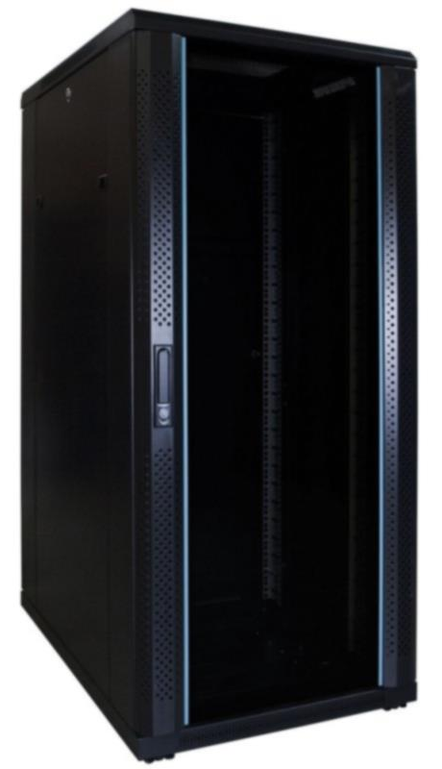
Figure 1- Server Rack

